Nitrogen Cycle WS Name:____________________________________

Directions: Use the diagram below and the information in the charts to answer the questions that follow.

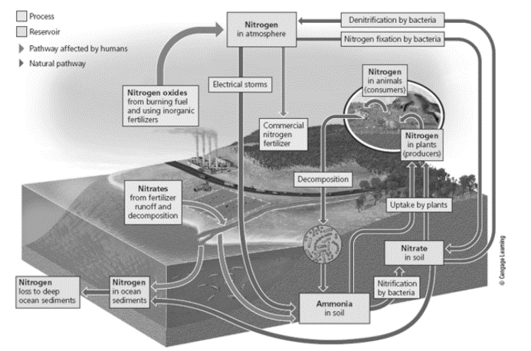
Key Terms: Nitrate (NO₃⁻) Nitrite (NO₂-) Ammonia (NH₃) Ammonium (NH₄⁺)

- The process below is called nitrogen fixation. Write a #1 next to this process on the diagram above.
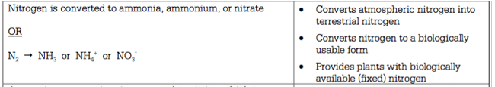
- In your own words, summarize nitrogen fixation below. Read the text in the chart above and put it into your own words.

- Draw a picture below to help you remember what happens during this process. You must label the picture.

4. The process below is called assimilation. Write a #2 next to this process on the diagram above.
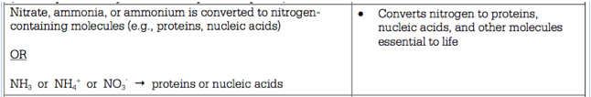
- In your own words, summarize assimilation below. Read the text in the chart above and put it into your own words.

- Draw a picture below to help you remember what happens during this process. You must label the picture.

- The process below is called denitrification. Write a #3 next to this process on the diagram above.
- What’s the difference between terrestrial and atmospheric nitrogen?

- In your own words, summarize denitrification below. Read the text in the chart above and put it into your own words.

- Draw a picture below to help you remember what happens during this process. You must label the picture.

- The process below is called decomposition. Write a #4 next to this process on the diagram above.
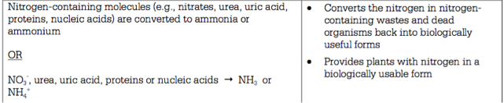
- What does ‘biologically useful’ mean?

- In your own words, summarize decomposition below. Read the text in the chart above and put it into your own words.

- Draw a picture below to help you remember what happens during this process. You must label the picture.

- The process below is called nitrification. Write a #5 next to this process on the diagram above.
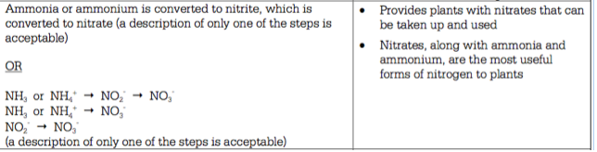
- In your own words, summarize nitrification below. Read the text in the chart above and put it into your own words.

- Draw a picture below to help you remember what happens during this process. You must label the picture.

