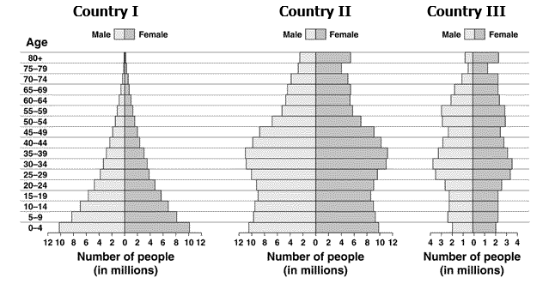
- Approximately how many people in Country 1 are below the age of 10?
- Which country shows negative growth? Rapid growth, slow growth?
- Give examples of countries at each location
- Uranium-235 has a half-life of 710 million years. If it is determined that a certain amount of stored U-235 will be considered safe only when its radioactivity has dropped to 0.10% of the original level, approximately how much time must the U-235 be stored securely to be safe? Express in exponential form.
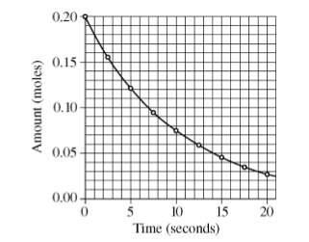
- Determine the half-life using the graph below?

- List metallic and non-metallic minerals.
- List benefits and drawbacks to hydropower, solar, wind, geothermal
- Explain desalinization.
- What are synfuels?
- Doubling time is the amount of time it takes for a given quantity to double in size or value at a constant growth rate. We can find the doubling time for a population undergoing exponential growth by using the Rule of 70. To do this, we divide 70 by the growth rate (r).
Note: growth rate (r) must be entered as a whole number and not a decimal. For example 5% must be entered as 5 instead of 0.05. dt = 70/r
For example, a population with a 2% annual growth would have a doubling time of 35 years.
70/2 Make some practice problems on your own!
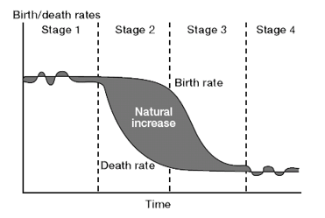
- Be able to explain birth and death rates at each Stage . Zero Pop Growth is at Stages? Where does pop. Slow?
- Calculate Crude Birth Rate
CBR=Total no. births/Total population x1000
Ex. In a village of 3829, there are twice as many male births than female births.
248 females were born. What is the CBR? Practice some more on your own.
- Define these EPA, FEMA, CCC, NEPA, NPP, GPP, SMCRA
- What are detritovores?
- How have ecological footprints changed over time? Why? Do all countries look the same? Explain!
- NPP = GPP – respiration Be sure you can calculate some problems
- What are estuaries? What services do they provide?
- Role of wetlands?
- What are causes to ocean acidification?
- What is ElNino? What happens during and El Nino period?
- If fertility rates decline, but population increases, what might be some reasons for this?
- Define: assimilation, nitrification, denitrification, ammonification, nitrogen fixation
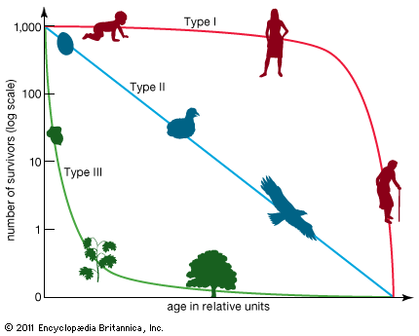
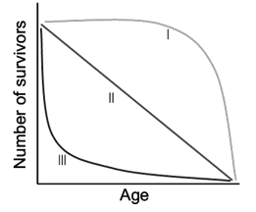
- Know this curve! What would be found at each type. What are characteristics at each Stage?

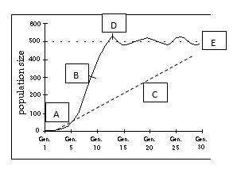
- Can you interpret this graph? Which letter shows exponential growth? Carrying capacity?
- What happens to ENERGY as you move up a pyramid? Where is the most and least energy?
- What role do decomposers play?
- Define Tragedy of the Commons.
- Illustrate a confined and unconfined aquifer.
- Why do urbanized areas often experience greater flooding than rural communities do?
- How do our aquifers recharge?
- Compare and contrast organic and synthetic fertilizers?
- What is a spoil bank? Tailings? Acid mine drainage?
- Differentiate between primary and secondary succession and give EX.!
- What is biomass and biofuels? What are advantages and disadvantages?
- If you have four 60 W bulbs in your house and you burn them for 3 hours per day, how many kWh are used in 1 year?
- Which countries have the highest per capita energy consumption?
- Which countries have the highest coal reserves?

