ABIOTIC FACTORS 1  long, cold winters;  short, cool summers;  moderate precipitation;  acidic, nutrient-poor soils | ABIOTIC FACTORS 2  low precipitation, variable temperatures; soils rich in minerals but poor in organic material | ABIOTIC FACTORS 3  mild temperatures; heavy rainfall, fertile soils that are susceptible to erosion and landslides
ABIOTIC FACTORS 4  hot and wet year-round;  thin, nutrient-poor soils | ABIOTIC FACTORS 5  cold to moderate winters;  warm to hot summers; year-round precipitation; fertile soils | ABIOTIC FACTORS 6  Slight seasonal variations in temperatures; distinct rainy seasons
ABIOTIC FACTORS 7  Mild, wet winters and warm, dry summers; semiarid, frequent fires, nutrient poor soil | ABIOTIC FACTORS 8  Warm year-round; rainfall highly seasonal with extremely heavy rain during wet season leading to soil erosion | ABIOTIC FACTORS 9  low precipitation; extremely cold winters and moderately cool summers; poorly developed soils; permafrost
ABIOTIC FACTORS 10
World’s most fertile soils, distinct temperature differences between winter and summer; limited precipitation

DOMINANT PLANTS 1  High numbers of intermixed tree species, large woody vines  and climbing plants; orchids  and bromeliads, epiphytes |  | DOMINANT PLANTS 2  woody evergreen shrubs with  small, leathery leaves; fragrant,  oily herbs that grow during  winter and die in summer, hot spot for diversity |  | DOMINANT PLANTS 3  A few species of evergreen trees, lichens
DOMINANT PLANTS 4  cacti and other succulents;  plants with thick, leathery leaves to reduce water loss |  | DOMINANT PLANTS 5  Deciduous plants that leaf out and grow profusely during times of rain, then drop their leaves in the dry season |  | DOMINANT PLANTS 6  broadleaf deciduous  trees such as oak, beech, and maple; some conifers;  flowering shrubs; herbs
DOMINANT PLANTS 7  lush, perennial grasses and  herbs |  | DOMINANT PLANTS 8  Coniferous trees such as cedars, spruce, hemlock, and Douglas fir |  | DOMINANT PLANTS 9  ground-hugging plants such  as mosses and lichens; low scrubby vegetation
DOMINANT PLANTS 10
Tall grasses, some trees
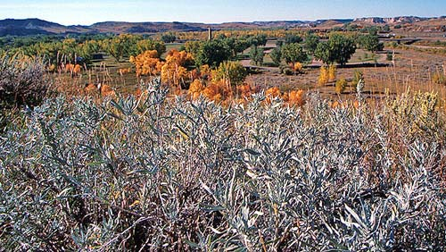  Reno, Nevada | 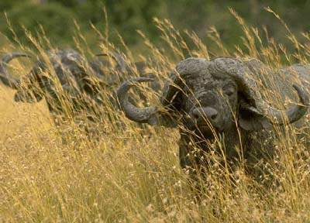  Harare, Zimbabwe |  | 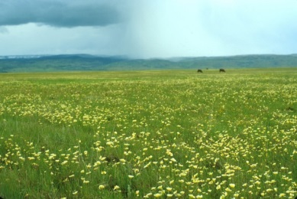  Lawrence, Kansas
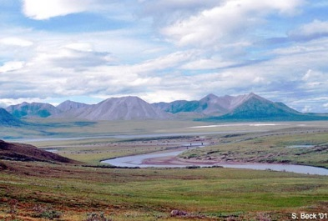  Fort Yukon, Alaska | 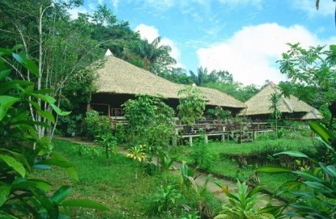  Manaus, Brazil |  | 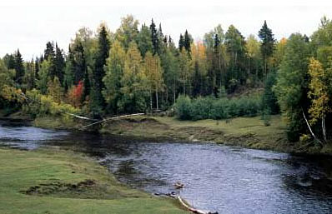  Moscow, Russia
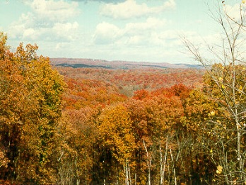  Montpelier, Vermont | 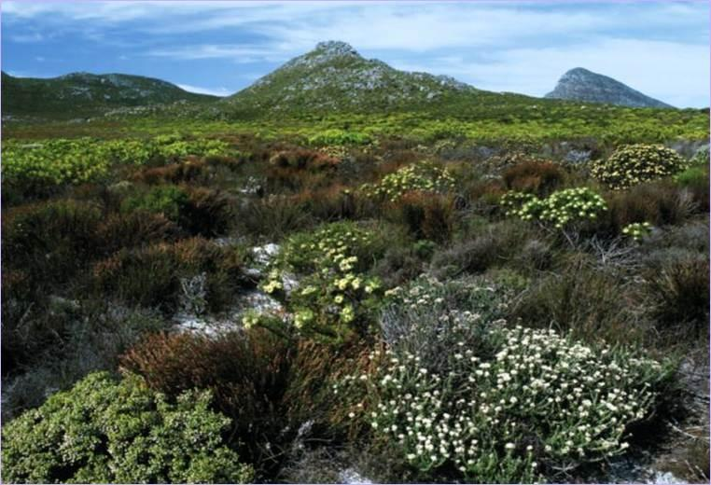  Lisbon, Portugal |  | 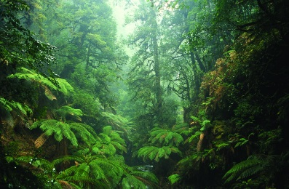  Eugene, Oregon
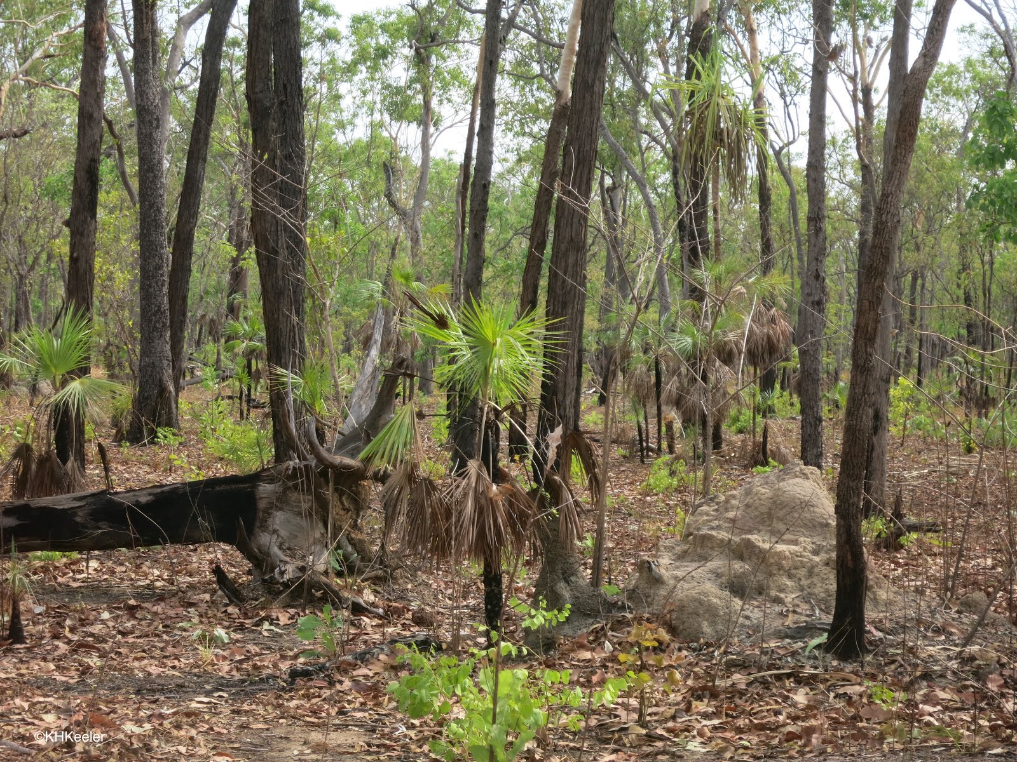  Darwin, Australia | 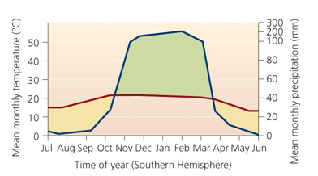  1 |  | 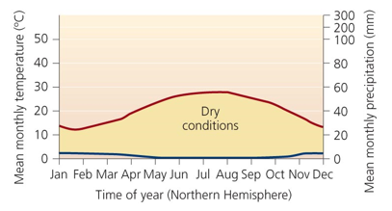  2
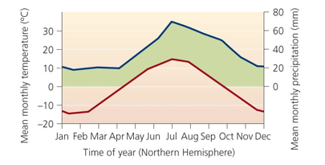  3 | 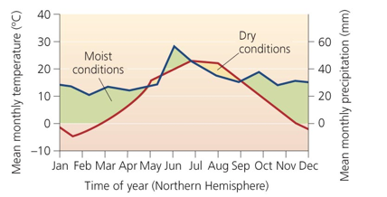  4 |  | 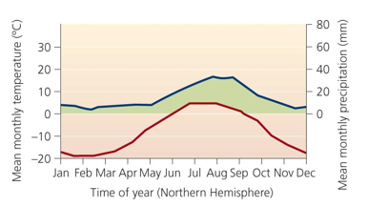  5
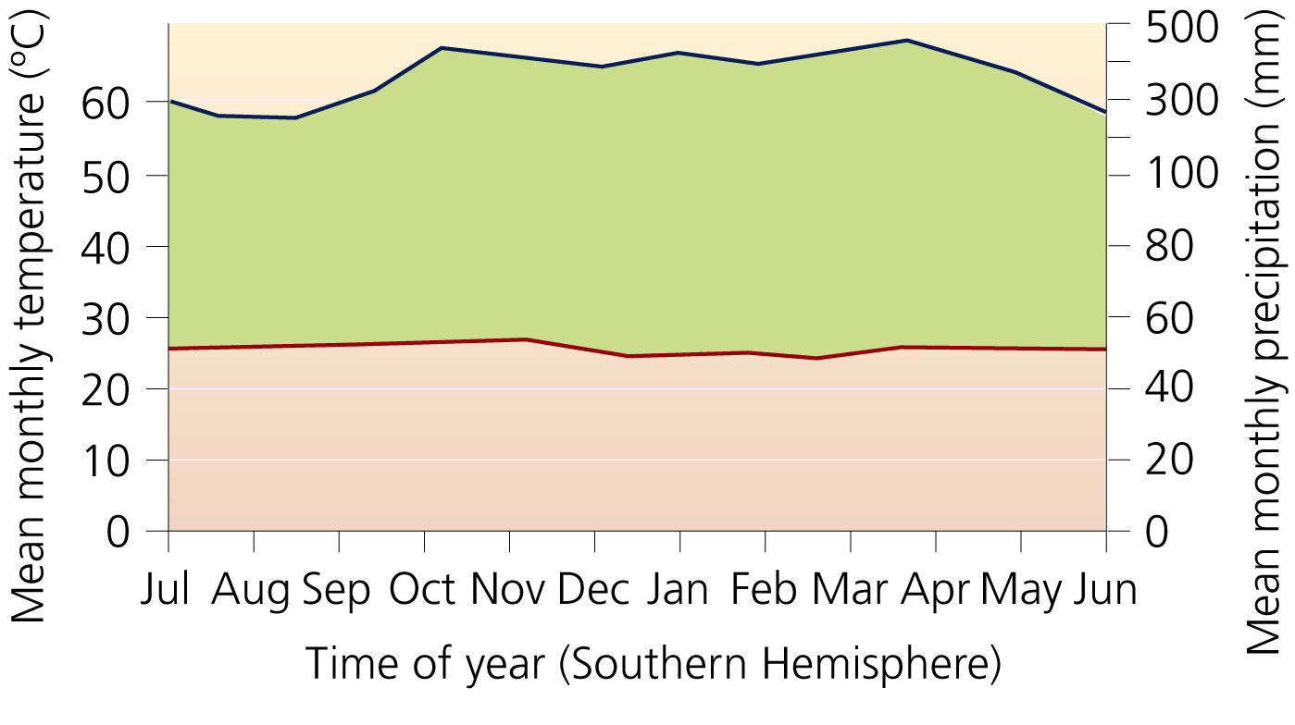  6 | 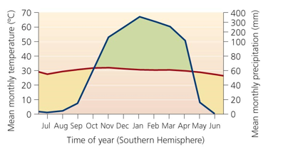  7 |  | 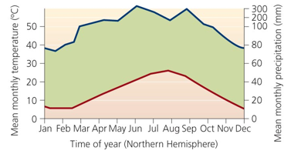  8
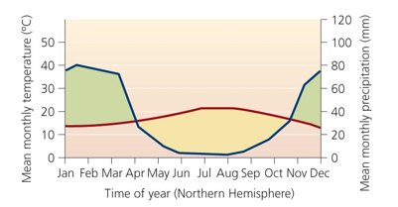  9 | 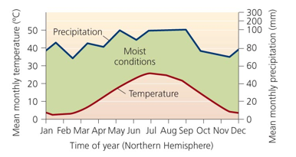  10

ANIMAL 1  Zebra, gazelle, giraffe, lion, hyena  Adaptation:  Migrate due to drought season; concentrate near widely spaced water holes | ANIMAL 2  Great numbers and diverse species of insects, birds, amphibians and various other animals  Adaptation:  Specialists | ANIMAL 3  Banana slug, spotted owl  Adaptation:  Moisture loving
ANIMAL 4  Deer, chipmunk, cottontail, toad, woodpecker  Adaptation:  Birds migrate, some animals may hibernate | ANIMAL 5  Moose, wolf, lynx, bear  Adaptation:  Birds migrate, rodents burrow, mammals may hibernate | ANIMAL 6  Prairie dog, bison, pronghorn antelope, meadolarks  Adaptation:  Birds nest on the ground
ANIMAL 7  Rattlesnakes, kangaroo mice  Adaptation:  Burrowing, nocturnal, nomadic | ANIMAL 8  Jackrabbits, coyotes  Adaptation:  Do not require much water | ANIMAL 9  Mosquitoes, caribou, polar bear  Adaptation:  migrate
ANIMAL 10
Monkey, puma, jaguar, deer, rodents
Adaptation:
Migrate, nocturnal

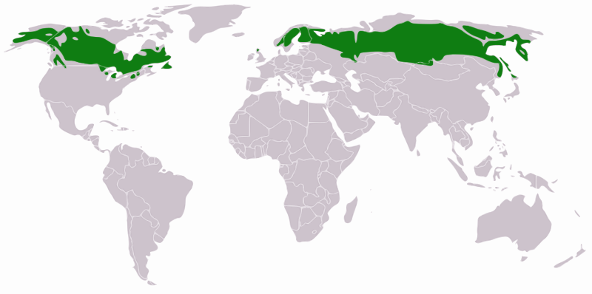  1 | 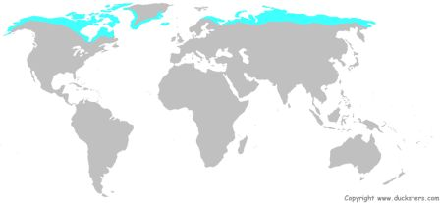  2 | 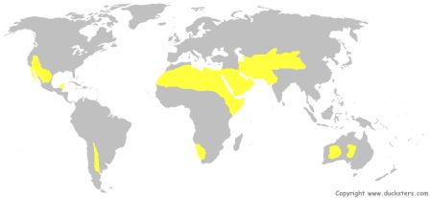  3
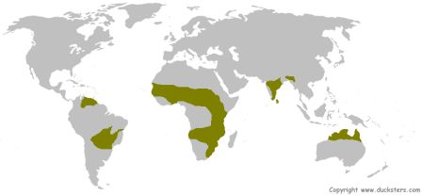  4 | 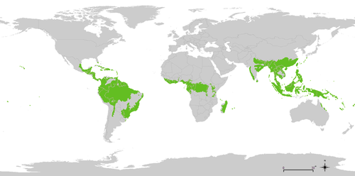  5 | 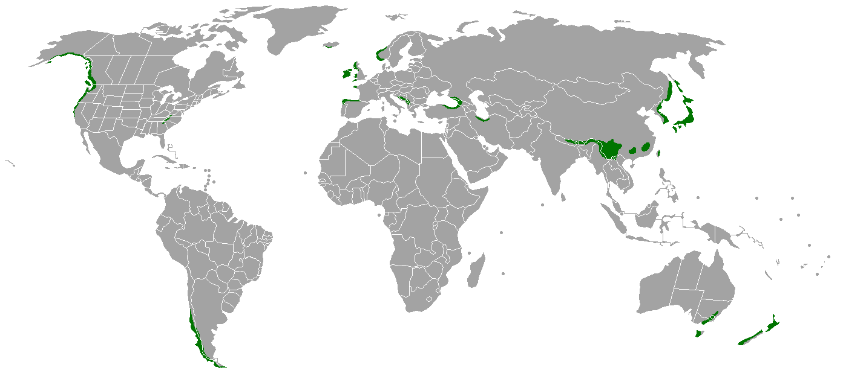  6
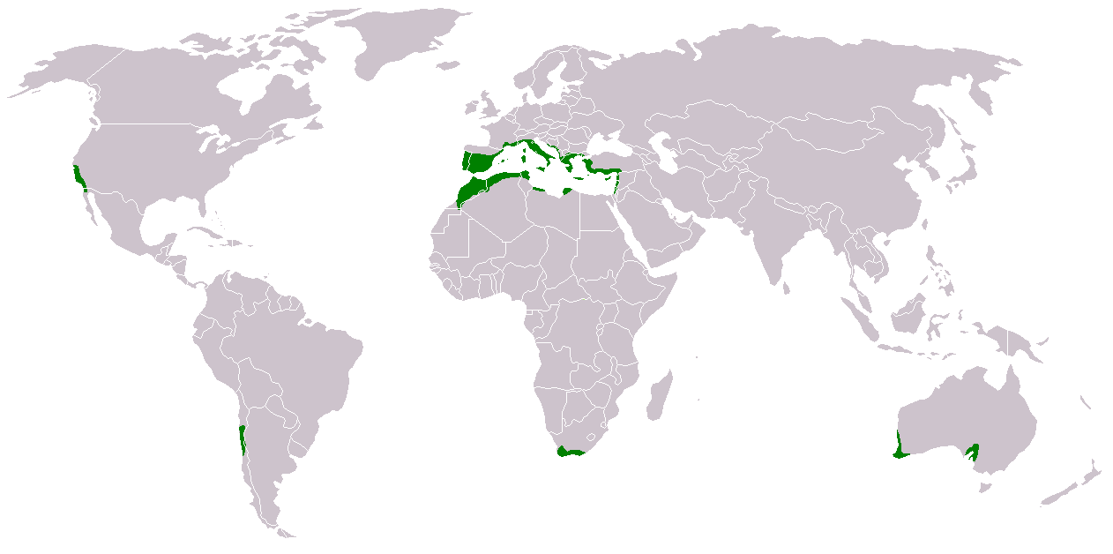  7 | 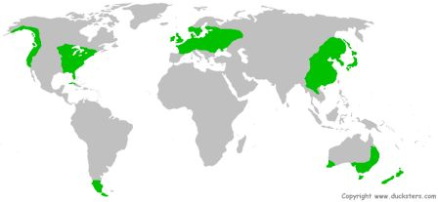  8 | 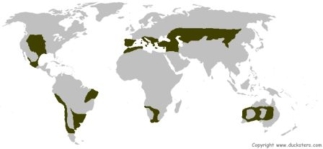  9
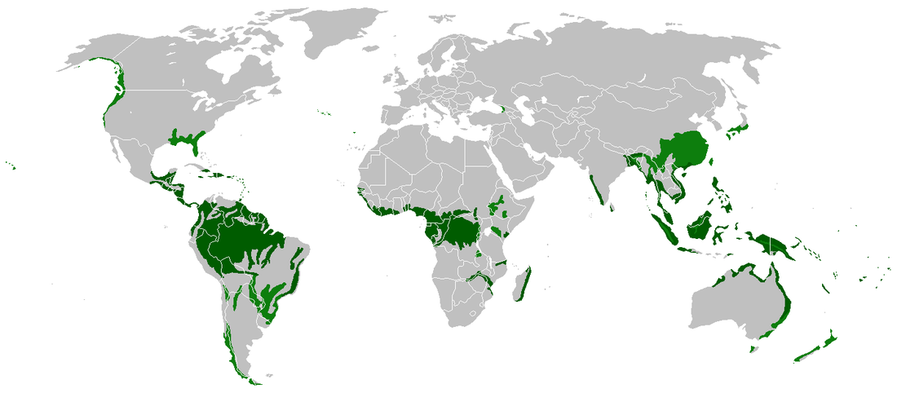  10  Anthropogenic 1  Airborne pollutants, melting of permafrost due to climate change, gas and oil development is a threat | Anthropogenic 2  Development due to Mediterranean climate | Anthropogenic 3  Cleared for logging, erosion of soil
Anthropogenic 4  Fragile ecosystems with fragile soils hurt by recreation vehicles | Anthropogenic 5  Clearing of land, overgrazing |  | Anthropogenic 6  Converted to agricultural use (farming and ranching); lost habitats – most animals exist at only a fraction of historic population size
Anthropogenic 7  Clearing of forests for farming - soil is unusable after a few years; logging | Anthropogenic 8  Severe soil loss occurs in areas where people have cleared forest due to extremely heavy rains in wet season. |  | Anthropogenic 9  Climate change, logging
Anthropogenic 10
Most lost biome due to development; logging

Terrestrial Biomes Booklet
In order to quickly review the characteristics of the 10 terrestrial biomes, you will be creating a booklet to showcase the most important information.
Materials needed:
3 sheets of plain, unlined paper
Biome booklet cards
Scissors and glue
Textbook and/or other reference materials

Procedure:
- Stack the 3 sheets of unlined paper and fold them to make a booklet.
- On the front cover, write the title, your name and your class period.
- At the top of each subsequent page of the booklet, write the name of one of the 10 major terrestrial biomes:
    - Desert
    - Tropical Savannah
    - Temperate Grassland
    - Arctic Tundra
    - Tropical Rain Forest
    - Tropical Dry Forest
    - Boreal Forest / Taiga
    - Temperate Deciduous Forest
    - Temperate Rain Forest
    - Chaparral
- Cut out the cards and sort them into the correct terrestrial biome.
- Glue each of the cards on the page for that biome.
- Study your booklet for your assessment!

Grading Rubric: DO NOT LOSE THIS SHEET!
 | Desert | Tropical Savannah | Temperate Grassland | Arctic Tundra | Tropical Rain Forest | Boreal Forest | Temperate Deciduous Forest | Temperate Rain Forest | Chaparral | Tropical Dry Forest
Location

Map

Graph

Plants

Animals

Abiotic

